Task 1: Develop a C program that demonstrates how a Linux operating system executes a command entered by a user that 1. Accept a Linux command as input. 2. Create a child process using fork(). 3. Execute the command in the child process using an appropriate exec() system call. 4. Allow the parent process to wait for the child using wait (). 5. Display the Process ID (PID) of both parent and child processes.
a) Write a C code to create a process using fork() system call.
b) Read the user input as shell command.
c) Use a system call exec() to execute the shell command.
e) Display the PIDs of parent and child processes.
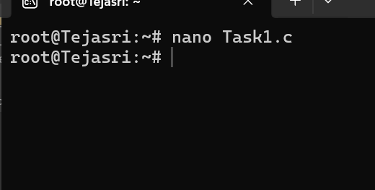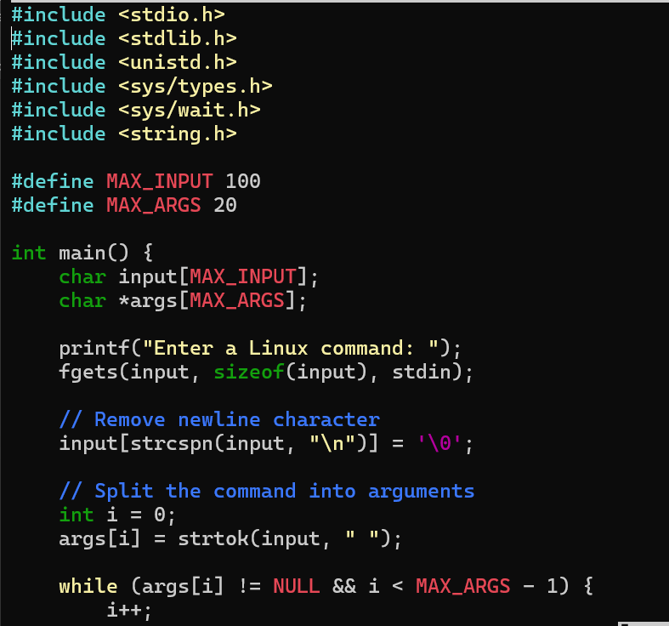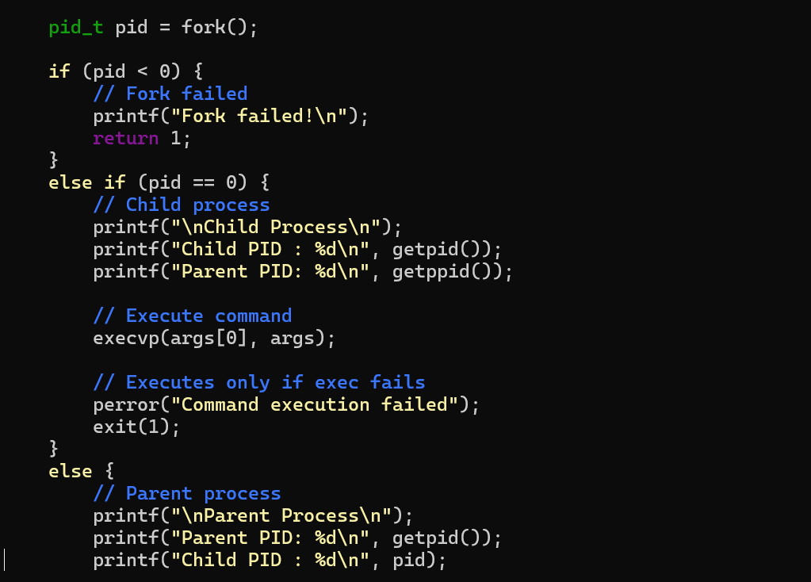
1)Then press
ctrl+o
enter
ctrl+x
2)then gcc filename.c -o filename
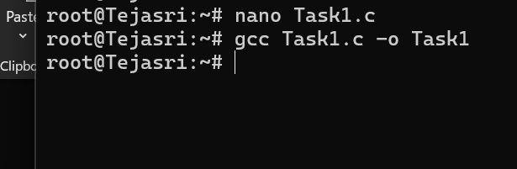

3)then ./filename
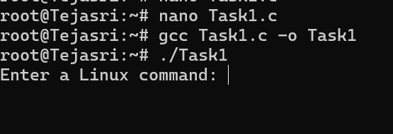
4)enter the linux command
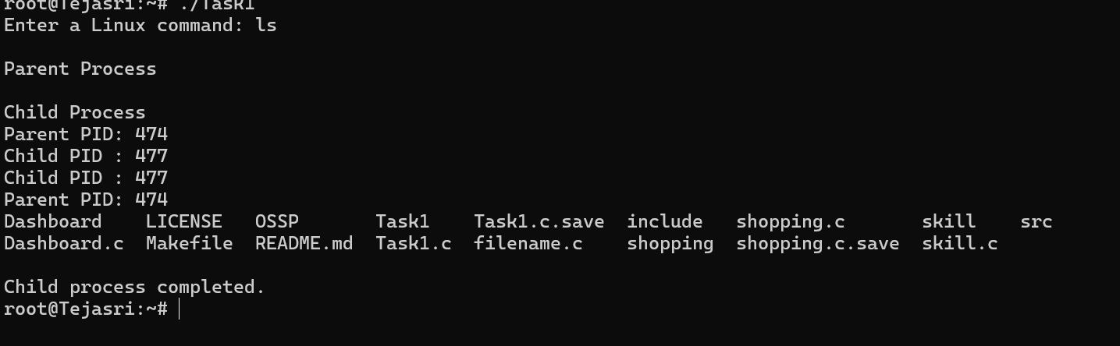
Child process completed.
Task 2
Using Linux terminal commands (uname, lscpu, ps, top), investigate the relationship between hardware resources and operating system services. Prepare a report explaining how the OS abstracts CPU, memory, storage, and I/O devices.
An operating system is system software that controls all the hardware and software resources of a computer. Users do not communicate directly with the hardware. Instead, the operating system acts as a bridge between the user, applications, and the hardware
Linux Commands Used
1. uname
The uname command is used to display information about the Linux operating system. It provides details such as the operating system name, kernel version, machine architecture, and hostname. This command helps us identify the system on which Linux is running.
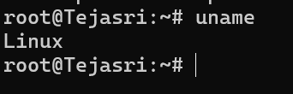
2. lscpu
The lscpu command displays detailed information about the processor. It shows the CPU model, number of cores, number of threads, CPU architecture, and processor speed. This information helps us understand the hardware capabilities of the computer.
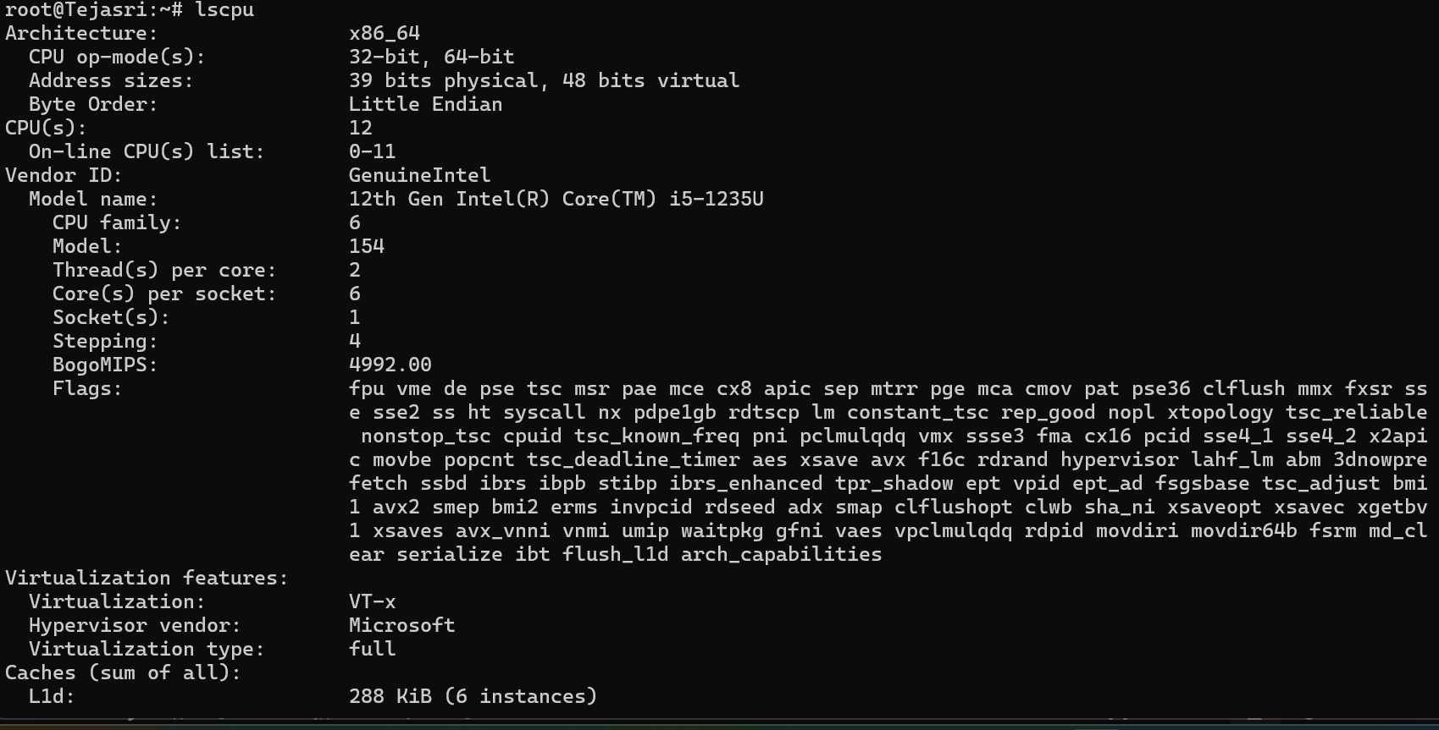
3. ps
The ps command lists the processes that are currently running in the system. It displays the Process ID (PID), Parent Process ID (PPID), user name, and the command associated with each process. This command is useful for monitoring and managing processes.
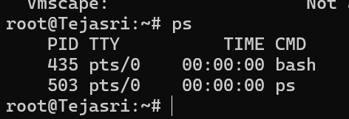
4. top
The top command provides a real-time view of the system's performance. It continuously displays CPU usage, memory usage, running processes, and system load. It is commonly used to identify programs that consume a large amount of system resources.
